Honey-Hole Brewing Company Delivery #1
October 14, 2024
Hope M. Turner, Chloe L. Webb
Professor Elainea Neville
Juniata College

Table of Contents
Abstract…………………………………………………………………………………………....3
Delivery #1………………………………………………………………………………………...4
Team Building, Motivation, and Communication Strategies…………………………………...5-7
Project Monitoring……………………………………………………………………………...…8
Project Management Plan…………………………………………………………………………9
Scope Statement………………………………………………………………………………….10
Milestone List & Risk Identification and Assessment Plan……………………………………...11
Figures……………………………………………………………………………………………12
Lessons Learned Report………………………………………………………………………….16
Transition Plan………………………………………………………………………………...…17

Roles
Project Sponsor…………………………………………………………………..Professor Neville
Project Manager(s)...................................................................................Hope Turner, Chloe Webb
Project Team…………………….Polly N. Ambrose, Ben Bumbleby, W. B. Buzz, Honey Combs,
…………………………………..Abbey B. Keeper, Beatrice Queen, Mason Stinger
Business Case……………………………………………………………………...Graphic Design
Abstract
Honey-Hole Brewing Company (HHBC) is a bar and distillery (opened in 2016) with steady, slowly increasing profits over the years. Remarkably, this independently owned bar and distillery managed to survive the COVID-19 pandemic. However, their sales seemed to have plateaued as of recently. Hoping to expand their business horizons and bring in more revenue, HHBC ventures to launch a new product to retail.

Honey-Hole Brewing Company Delivery #1
Honey-Hole Brewing Company (HHBC) is a bar and distillery (opened in 2016) with steady, slowly increasing profits over the years. Remarkably, this independently owned bar and distillery managed to survive the COVID-19 pandemic. However, their sales seemed to have plateaued as of recently. Hoping to expand their business horizons and bring in more revenue, HHBC ventures to launch a new product to retail.
Objective
Design a marketable label for a new product line (bottled beverages) that will be sold in HHBC and retail.
Assumptions
The design should match the company’s brand identity. It should be eye-catching, unique, and recognizable, yet not overly flashy. It should also proportionately fit the bottle label size.
Constraints. The size of the bottle label.
Preliminary Requirements. Design a prototype logo. Then make revisions as suggested by the sponsor. Publish final design on bottles.
Budget Estimate. $3,000
Schedule Estimate. Five month timeframe.
Success Criteria. Produce a prototype logo within the first two months of the project schedule. Meet with the sponsor to get feedback and suggestions. Finalize the design that will appear on the product.

Team Building, Motivation, and Communication Strategies
Team Building and Motivation
As a group of artists, team building and motivation is pretty unconventional. Many of us have short attention spans, so team building exercises and ways to keep motivated are usually fast-paced and engaging. We also enjoy a more relaxed work environment instead of stuffy formalism between co-workers. That is to say, many of our team building exercises are game nights; like multiplayer video games, board games, or other interactive, low-stress challenges, that usually someone on the team comes up with. We recently did a ‘bake-off’, which was essentially a potluck but for sweets. We also do movie nights and occasionally weekend get-togethers. Team motivation looks similar. To stave off the mighty beast known as Art Block, we do quick little art challenges, usually once a week to refresh the team creatively. We recently did ‘sketch your D&D character; if you don’t have one, imagine yourself as one’.
For this project specifically, we took one of these weekend gatherings to Honey-Hole Brewing Company (HHBC) to get an idea of what their aesthetic and flavor profile was like. We made sure to sample the brew that is going to be turned into a bottled product, to get early inspiration for the label design. We’ve been maintaining motivation by not discouraging the artists if they’re designs aren’t considered for the prototypes. We want our team to feel like they’re efforts meant something. We still value their feedback and have done our best to incorporate the most popular elements from each artist’s concept into the deliverables.
Communication Strategies
In any project, especially one involving creative elements, such as the design of a marketable product label, effective team communication is critical to project success. The Honey-Hole Brewing Company (HHBC) project involves a team of artists, project managers, and clientele. Communication strategies must be tailored to this project with the team in mind to ensure successful collaboration, clear direction, and timely deliverables.
To begin, effective communication starts with shared understanding of the project’s scope. When starting the label design project, it is essential that all team members are briefed on HHBC goal’s, brand identity, and specific requirements. This can be achieved through organizing a kickoff meeting that includes the entire team and stakeholders from HHBC. This meeting would go over objectives, success criteria, budget, and timeline. Throughout the project, information regarding it should be properly documented and circulated throughout the team. We want to make sure everyone is on the same page after all. Furthermore, regular progress updates are required so that everyone is on track and issues can be identified early. This would include weekly stand-up meetings, lasting around thirty minutes at most, allowing the team to share updates. Since artists and designers may face challenges or blocks, suggestions from other members should keep the project moving smoothly. Additionally, hosting milestone reviews after every design phase of the label allows stakeholder feedback to be gathered and dispersed throughout the team.
A project like this can extremely benefit from fostering a collaborative and creative environment. Thus, the communication channels should reflect this, while maintaining professionalism and productivity. Using collaboration tools, such as Slack or Microsoft Teams, will allow our team to stay connected in real-time from anywhere. These tools offer chat functions, video conferencing, and file sharing, making them ideal for quick questions and idea exchanging at any given moment. In addition to formal meetings, brainstorming sessions can be held for the team to share initial ideas. These sessions should encourage free thinking, open discussion, and feedback. Using a visual tool, such as Canva or the Adobe Creative Cloud Suite may help the team sketch out their ideas, while also allowing for better explanations. During meetings, feedback from our stakeholders should be collected in a structured way, such as through specific questions (i.e. Colors, logo placement, fonts, etc.).
Overall, encouraging open dialogue will allow an environment to form where team members feel comfortable voicing their opinions and concerns. Holding regular retrospectives can promote proper reflection and foster continuous improvement towards communication. If unforeseen challenges arise, the project manager(s) should have a backup plan in place. This could involve reallocating tasks or adjusting timelines while keeping the stakeholders informed.

Project Monitoring
Effective project monitoring is crucial for ensuring that the design and launch of HHBC’s new product line stays on track, within budget, and meets defined success criteria. To monitor the progress of this project, we will implement a structured approach that includes regular check-ins, performance tracks, and early identification of any issues that may affect the timeline or quality of deliverables.
To begin, we will break the project into key milestones, such as completing the prototype logo, gathering sponsor feedback, and finalizing the design. Regular milestone reviews will help to assess if the project is on track. Secondly, weekly team meetings will be held to review ongoing tasks and resolve any issues. During these, team members will provide updates on their progress, including any challenges that they are facing. Next, we will use a project management dashboard tool, such as Trello, that will be shared amongst team members. Furthermore, feedback from the project sponsor will be gathered regularly to ensure the design aligns with their expectations and brand identity. Lastly, risks will be continuously assessed throughout the project, and a risk log will be maintained. If any are identified, a mitigation plan will be developed. By using these monitoring strategies, we can maintain control over the project, ensuring that the design for HHBC’s new product line is delivered properly. Regular monitoring and adjustment will help ensure the project stays aligned with the goals and priorities of the team and client.

Project Management Plan
- Summary of Charter
- Scope Statement
- Milestones and Estimated Completion
- Subsidiary Plans
  - Schedule Management
  - Cost Management
  - Quality Management
  - HR Management
  - Communications Management
  - Risk Management
  - Stakeholder Management
- Finalization Plan
  - Sponsor meeting and approval
  - Successful and punctual delivery
  - Gauge success criteria, lessons learned
Title: HHBC Label Design | Number: 1
Manager(s): Hope Turner, Chloe Webb | Start Date: 8/1/2024
Sponsor: Professor Neville | Date Prepared: 12/1/2024
Risk Level: Low | Estimate Completion Date: 12/31/2024

Scope Statement
Objective: Design a marketable label within 6 months and a $3,000 budget.
Justification: Bring in more revenue to Honey-Hole Brewing Company. Income for commission graphic design artists.
Deliverables: Prototype Design. Revised Design. Final Design.
Milestones: Prototype Label Designs - Estimated September 30th. Revised Label Designs - Estimated October 31st. Final Label Submission - Estimated November 30th.
Cost Estimate: $3,000
Risks: Vastly conflicting designs may lead to a scheduling risk. Client cooperation is a production risk.
Constraints: Application: Design needs to fit proportionally and make sense on the physical product.
Assumptions: Schedule is a reasonable timeframe for a small team of commission artists. The client will be reasonable with expectations and suggestions.
Technical Requirements: Bottling company responsible for putting labels on products. Make sure files are shareable and can be distributed despite internet complications. Keep software up to date.
Customer Reviews: Bi-monthly meetings (on average) with client; two meetings with Professor Neville (Sponsor).

Milestone List
Milestone | Description | Date Due
Project Start | Begin official project after meeting with team and sponsor | 8/1/2024
Prototype Label Designs | Initial label design creation and review submission | 9/30/2024 (Internal, Flexible)
Feedback Meeting | Meeting with HHBC to gather feedback | 10/1/2024 (External, Mand.)
Revised Label Designs | Make design revisions based on feedback | 10/31/2024 (Internal, Flex.)
Final Design Approval | Final sponsor and client meeting for label design approval | 11/1/2024 (External, Flex.)
Final Label Submission | Submit final print-ready deliverables | 11/30/2024 (External, Mand.)
Project End | Project officially closed with all deliverables met | 12/1/2024 (External, Mand.)
Risk Identification and Assessment Plan
# | Risk | Description | Probability | Severity | Response
1 | His ass is NOT an artist!! | The client has no artistic background or skill, so may make suggestions that are bad for marketing or simply aren’t feasible. He is also notoriously stubborn. This could lead to conflicts with our working relationship if we constantly bump heads. | Moderate | Moderate | Be elaborate as to why suggestions would or would not be practical
2 | Group disagreement | This team is made up of different graphic design artists, and each will bring their own vision to this assignment. While collaboration and a united design will result in the final product, it cannot be neglected that team members will naturally want to see their effort acknowledged. However, if team members are unwilling to compromise, we will have an issue. | Moderate | High | Regularly check-in with team members, outside of work preferably, allow them to vent. We will also try our very best to incorporate something from each artist
3 | Product recall/failure | If the bottles don’t do well in stores, we lose that commission bonus and potentially bad PR. | Moderate | High | Check in with HHBC and sponsor about profit concerns
Figures
SWOT Analysis
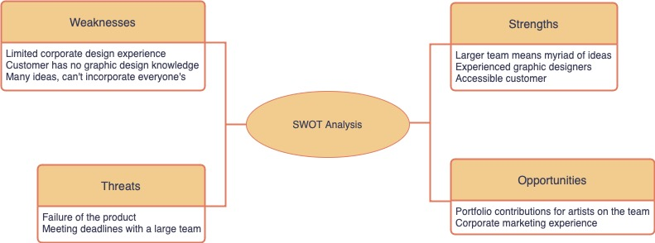
NPV Calculation
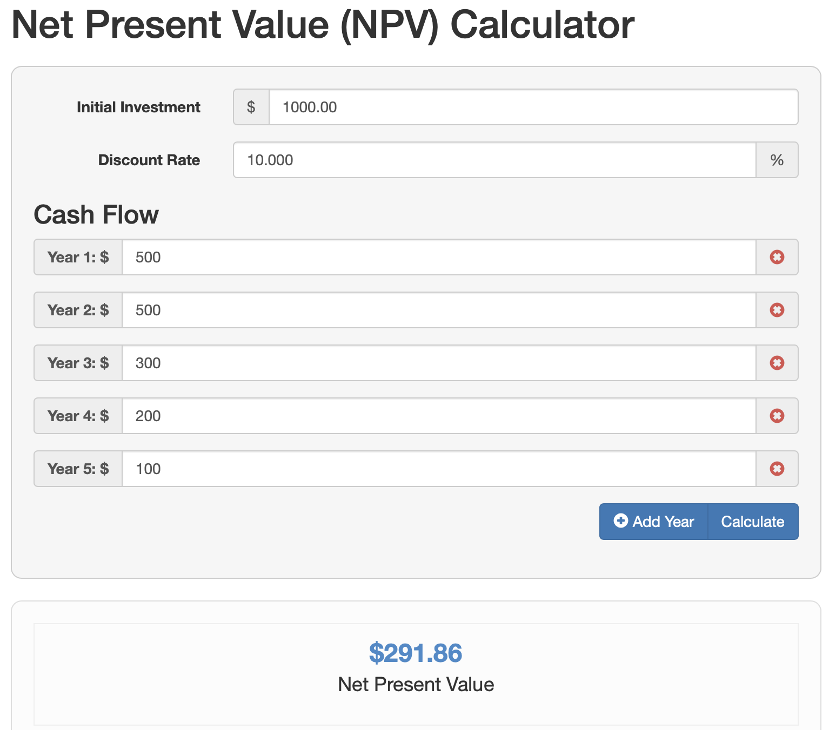
Payback Period
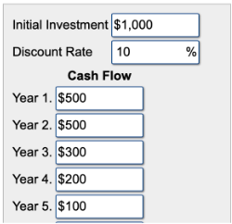
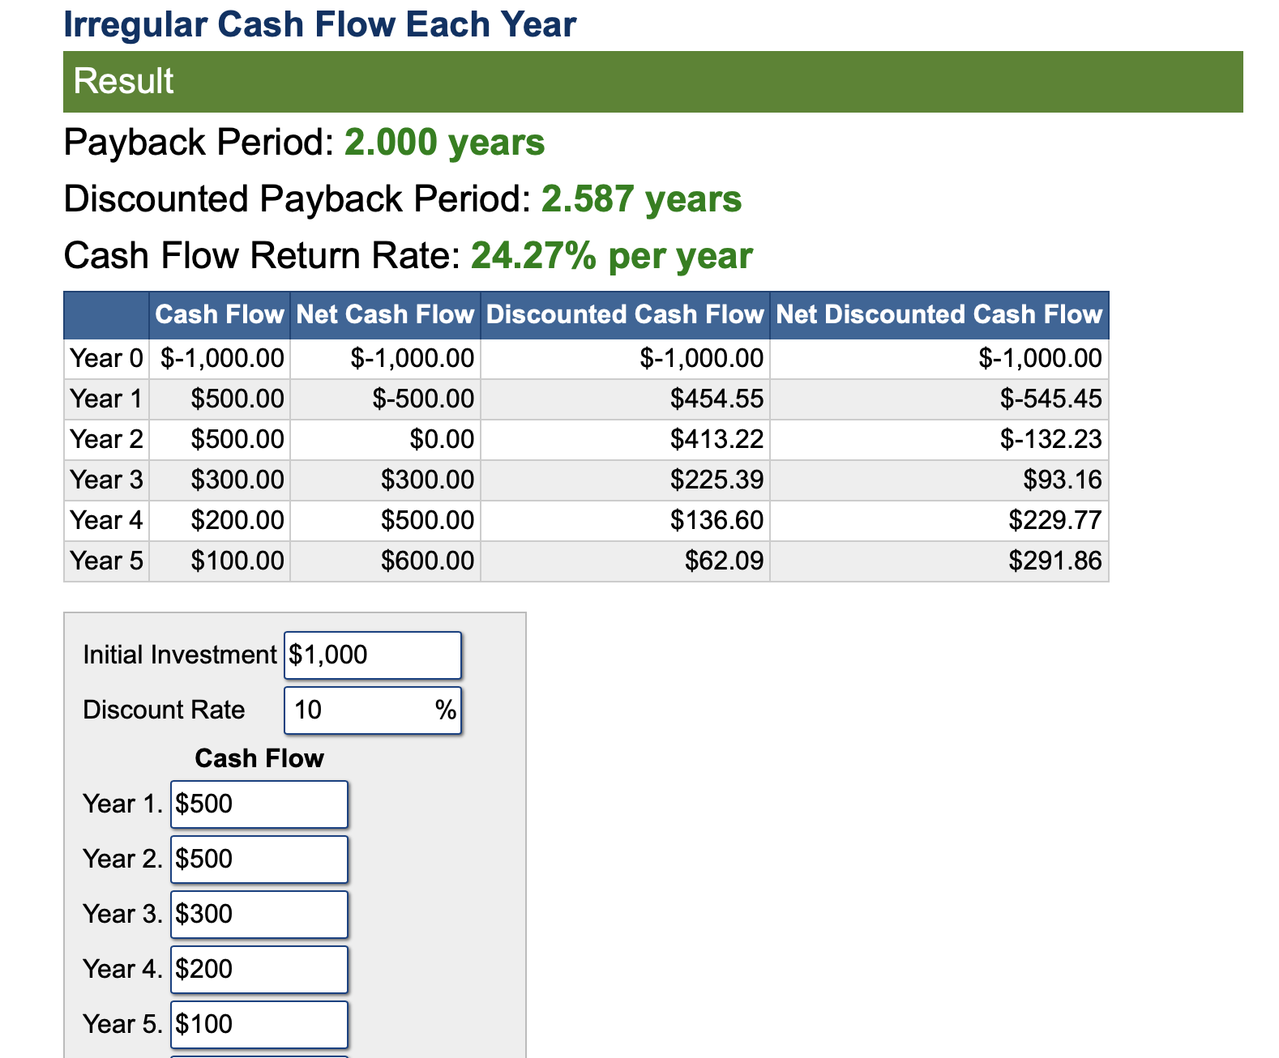
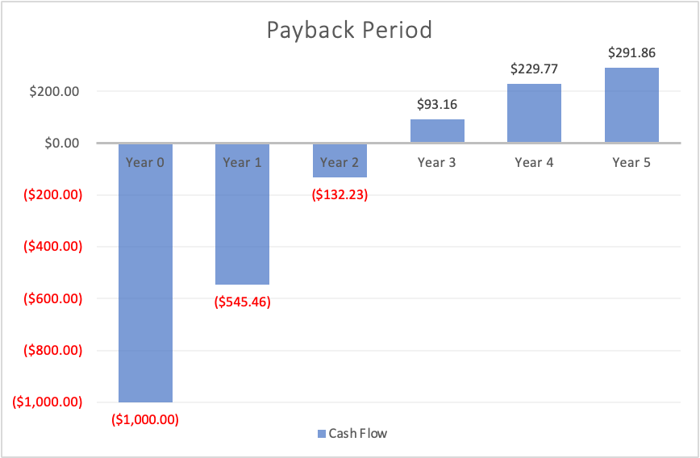
ROI
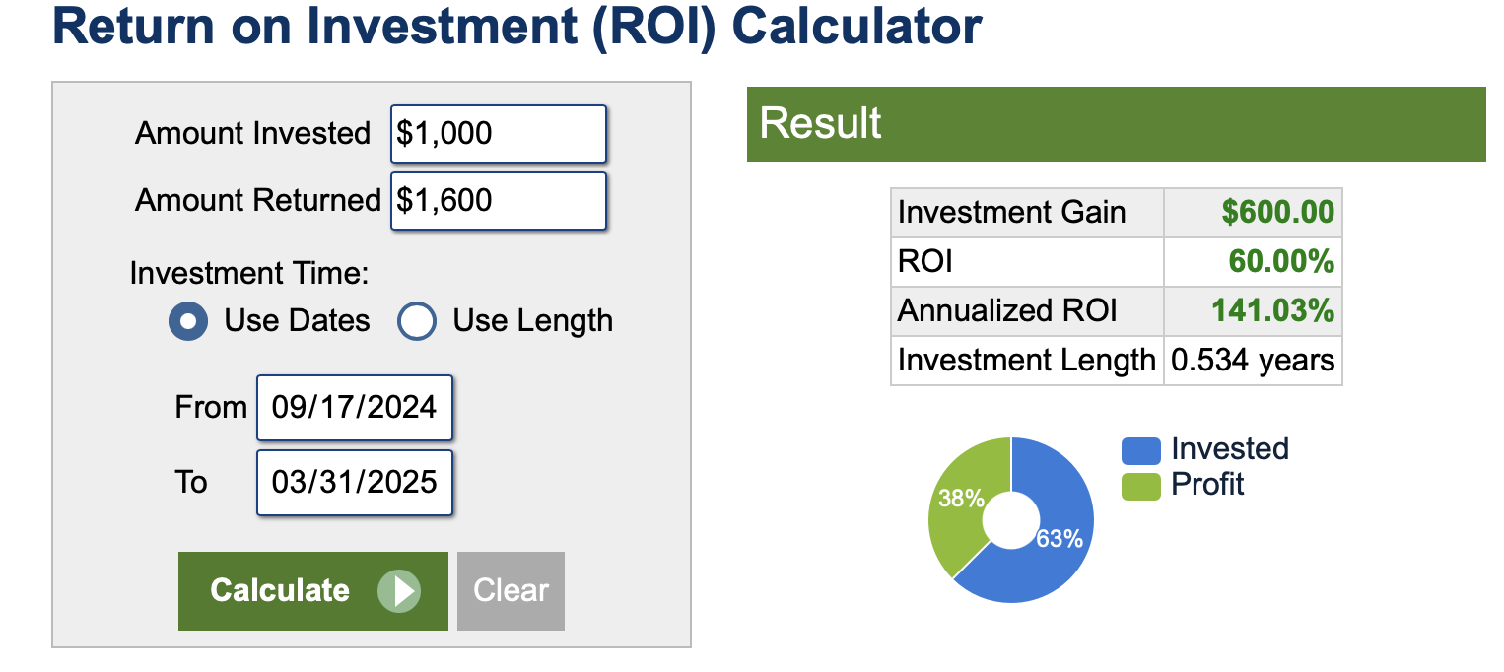
WBS Chart
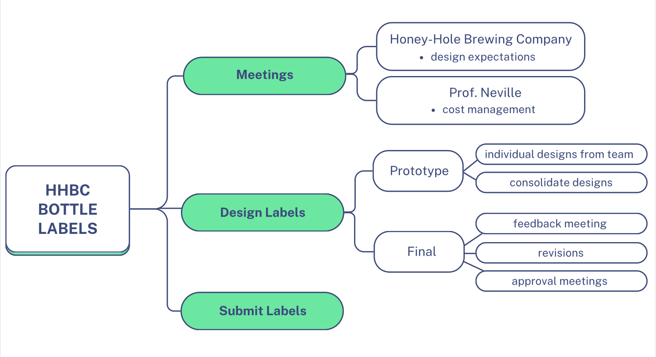
GANTT Chart
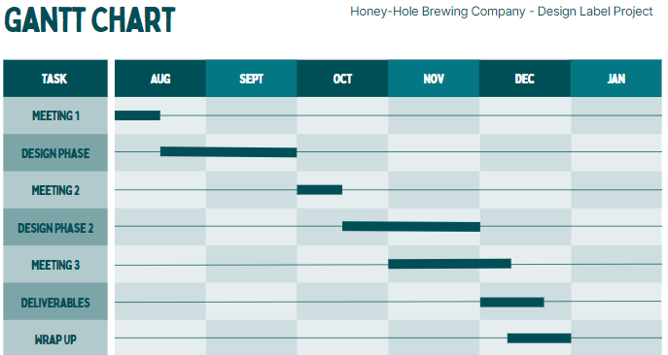
Critical Path Analysis
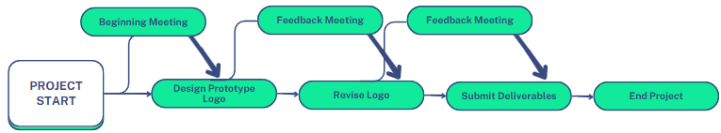

Change Management Plan
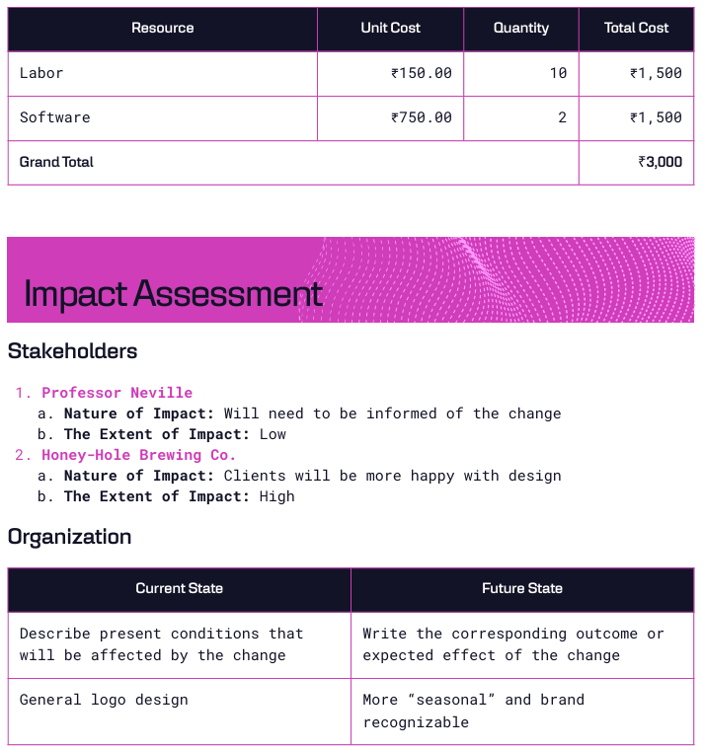
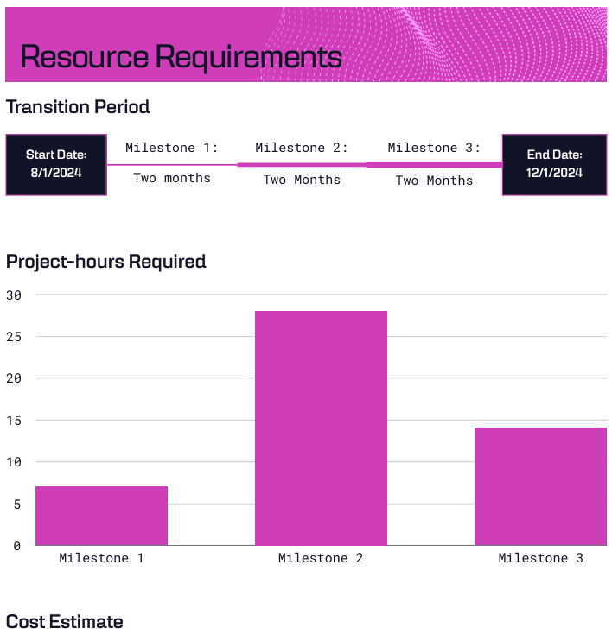
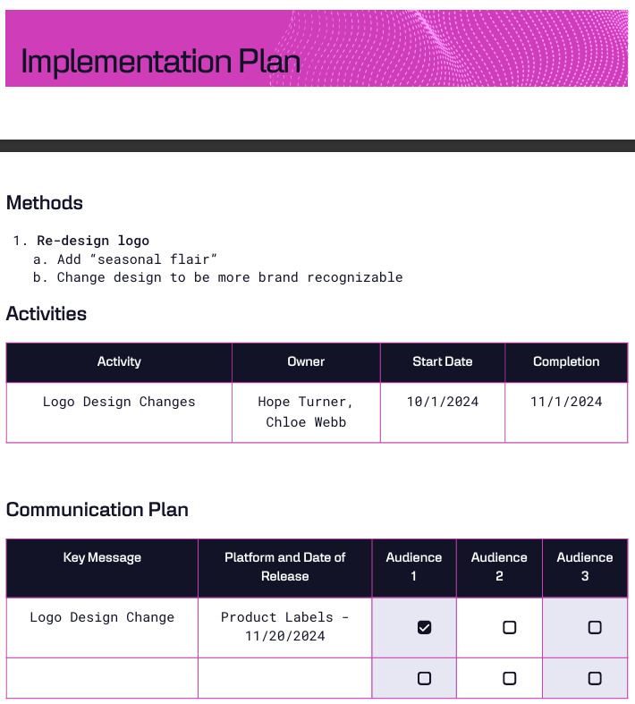
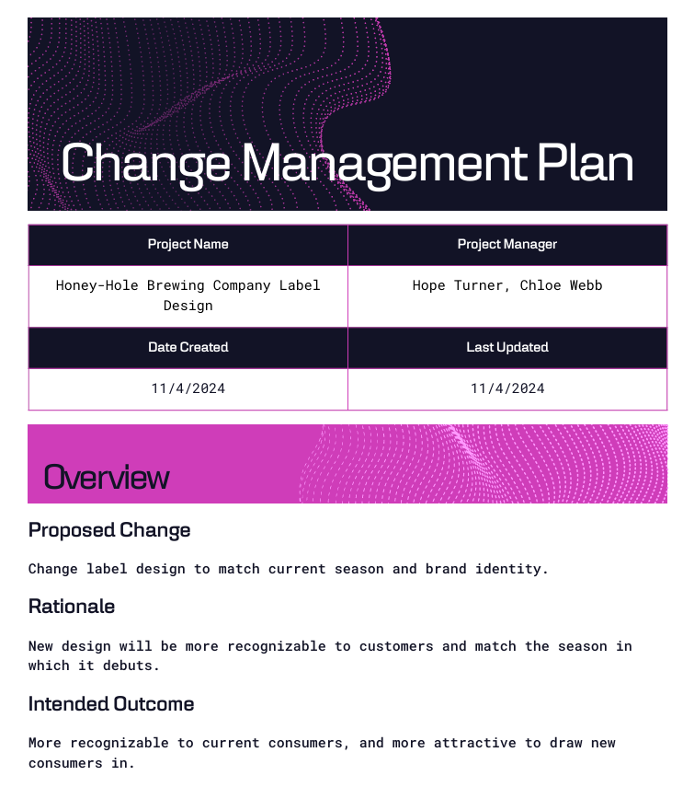
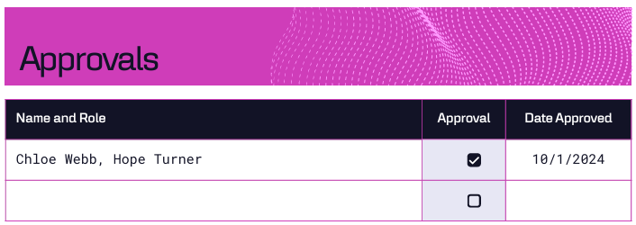

Lessons Learned Report
11/20/2024
Project Name: Honey-Hole Brewing Company Delivery #1
Project Sponsor: Professor Elainea Neville
Project Manager(s): Hope Turner and Chloe Webb
Project Dates: August 1st 2024 - December 31st 2024
Final Budget: $4,095.07
1. Did the project meet scope, time, and cost goals?
We went slightly over our estimated budget but did not blow it out of proportion.
2. What was the success criteria listed in the project scope statement?
Produce a prototype logo within the first two months of the project schedule. Meet with the sponsor to get feedback and suggestions. Finalize the design that will appear on the product.
3. Reflect on whether or not you met the project success criteria.
We did, as the team worked very efficiently with the client (HHBC) and overcame all challenges.
4. What were the main lessons your team learned from this project?
How to work artistically, creatively, and collaboratively to produce packaging with marketing in mind.
5. Describe one example of what went right on this project.
The client was pleased with the initial design, but requested simple changes to better match their brand identity. Thus, we started off already fairly close to what the client wanted.
6. Describe one example of what went wrong on this project.
Our design software we use updated and ended up corrupting some files that were unable to be restored. One artist’s tablet stopped working entirely. Thankfully, they’re files are stored on their iCloud and could be recovered.
7. What will you do differently on the next project based on your experience working on this project?
For one, artists will be encouraged to keep a backlog of saved drafts in each step of a design they work on, in case something like this happens again. Secondly, we will likely assemble a smaller team to speed-up the drafting process.

Transition Plan
11/20/2024
Project Name: Honey-Hole Brewing Company Delivery #1
Introduction
Design a marketable label for a new product line (bottled beverages) that will be sold in HHBC and retail.
Assumptions
Project Manager(s) are in active email communication with executives of the chosen warehouse that will produce the bottles and print the labels onto them.
The chosen warehouse will ensure quality control; that labels are printed on correctly, in full color and resolution before sending them out.
The client from HHBC will also be in contact with this third party as well, and will communicate estimated and expected delivery dates effectively.
Organization: L. Abel’s Labeling & Bottling Factory
Work Required
The main work required to support the products/services developed from this project includes:
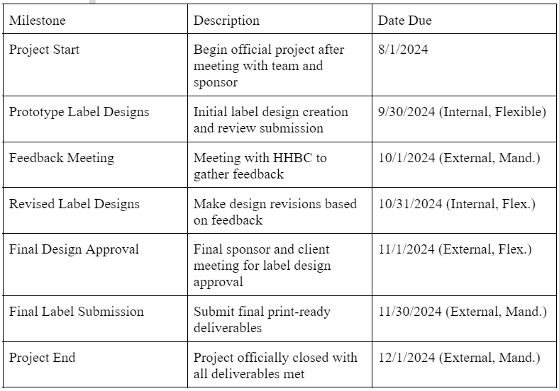
Active design work in our softwares and feedback communication with HHBC.
Schedule

